 | Pimpri Chinchwad Education Trust’s  Pimpri Chinchwad College of Engineering
Experiment No. 8
Experimentation details
Department: E&TC Academic Year: 2025-26 Semester-I
Class: B.Tech E&TC Course: VLSI Design Lab

Name of Student:
Div and Batch:
Roll No:
Title of the Experiment:
Model and verify Modulo-N-Counter (MOD_N) using VHDL and implement on FPGA and evaluate power and timing performance

Software Requirements: Xilinx 14.7 ISE Design Suite
Hardware Requirements: Xilinx Spartan-6 XC6SLX45 FPGA

VHDL Code for MOD N Counter

library IEEE;
use IEEE.STD_LOGIC_1164.all;
use ieee.std_logic_arith.all;
use ieee.std_logic_unsigned.all;

entity modN_counter is

generic(n: integer := 128);

port(
clk : in STD_LOGIC;
reset : in STD_LOGIC;
dout : out STD_LOGIC_VECTOR(6 downto 0)
);
end modN_counter;
architecture A_modN of modN_counter is
begin
counter : process (clk,reset) is
variable m : integer range 0 to (n-1) := 0;
begin
if (reset='1') then
m := 0;
--elsif (rising_edge (clk)) then
elsif(clk'event and clk='1') then
m := m + 1;
end if;
if (m=(n)) then
m := 0;
end if;
dout<= conv_std_logic_vector (m,7);
end process counter;
end A_modN;
RTL Schematic
Block Diagram of Design
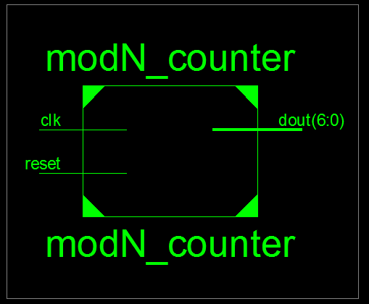

Detailed Schematic
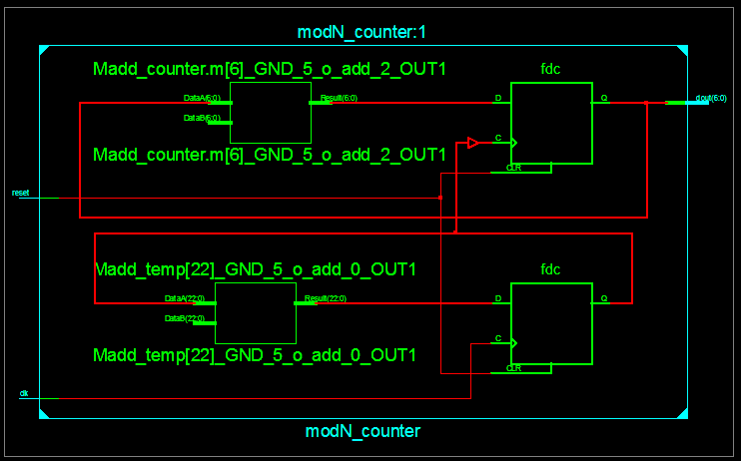

VHDL Test Bench
LIBRARY ieee;
USE ieee.std_logic_1164.ALL;
-- Uncomment the following library declaration if using
-- arithmetic functions with Signed or Unsigned values
--USE ieee.numeric_std.ALL;
ENTITY MOD_TB IS
END MOD_TB;
ARCHITECTURE behavior OF MOD_TB IS
-- Component Declaration for the Unit Under Test (UUT)
COMPONENT modN_counter
PORT(
clk : IN std_logic;
reset : IN std_logic;
dout : OUT std_logic_vector(6 downto 0)
);
END COMPONENT;

--Inputs
signal clk : std_logic := '0';
signal reset : std_logic := '0';

--Outputs
signal dout : std_logic_vector(6 downto 0);

-- Clock period definitions
constant clk_period : time := 10 ns;
BEGIN
-- Instantiate the Unit Under Test (UUT)
uut: modN_counter PORT MAP (
clk => clk,
reset => reset,
dout => dout
);
-- Clock process definitions
clk_process :process
begin
clk <= '0';
wait for clk_period/2;
clk <= '1';
wait for clk_period/2;
end process;

-- Stimulus process
stim_proc: process
begin
-- hold reset state for 100 ns.
--wait for 100 ns;
reset<='1';
wait for 10 ns;
reset<='0';

-- insert stimulus here

wait;
end process;

END;
Simulation Results
MOD128
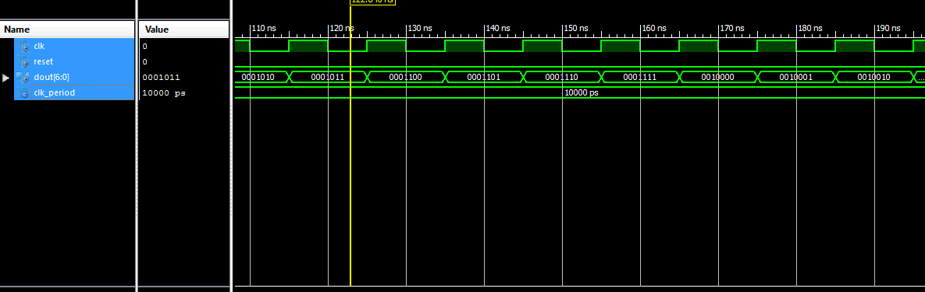

Implementation on Spartan 6
MOD 128
library IEEE;
use IEEE.STD_LOGIC_1164.all;
use ieee.std_logic_arith.all;
use ieee.std_logic_unsigned.all;

entity modN_counter is

generic(n: integer := 128);

port(
clk : in STD_LOGIC;
reset : in STD_LOGIC;
dout : out STD_LOGIC_VECTOR(6 downto 0)
);
end modN_counter;

architecture A_modN of modN_counter is
signal temp:std_logic_vector(22 downto 0);
signal sclk:std_logic;

begin

p11: process(clk,reset)
begin
if(reset='1')then temp<=(others=>'0');
elsif(clk'event and clk='1') then
temp<= temp + 1;
end if;
end process;
sclk<=temp(22);

counter : process (sclk,reset) is

variable m : integer range 0 to (n-1) := 0;
begin
if (reset='1') then
m := 0;
--elsif (rising_edge (clk)) then
elsif(sclk'event and sclk='1') then
m := m + 1;
end if;
if (m=(n)) then
m := 0;
end if;
dout<= conv_std_logic_vector (m,7);
end process counter;

end A_modN;

Device Specifications to be selected while implementing:
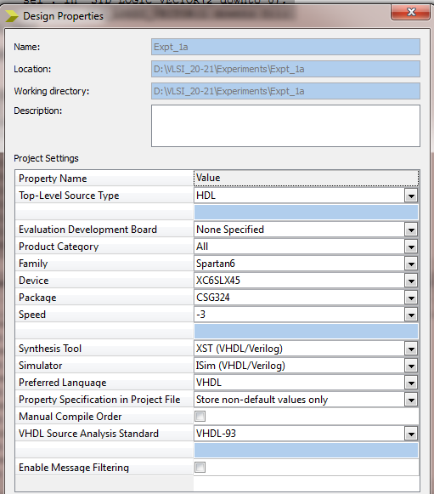

Implementation Constraint File
NET "reset" LOC = "E4";
NET "CLK" LOC ="L15";
NET "dout<0>" LOC = "U18"; # Bank = 1, Pin name = IO_L52N_M1DQ15, Sch name = LD0
NET "dout<1>" LOC = "M14"; # Bank = 1, Pin name = IO_L53P, Sch name = LD1
NET "dout<2>" LOC = "N14"; # Bank = 1, Pin name = IO_L53N_VREF, Sch name = LD2
NET "dout<3>" LOC = "L14"; # Bank = 1, Pin name = IO_L61P, Sch name = LD3
NET "dout<4>" LOC = "M13"; # Bank = 1, Pin name = IO_L61N, Sch name = LD4
NET "dout<5>" LOC = "D4"; # Bank = 1, Pin name = IO_L61P, Sch name = LD3
NET "dout<6>" LOC = "P16"; # Bank = 1, Pin name = IO_L61P, Sch name = LD3
#NET "dout<7>" LOC = "N12";
Implementation Successful
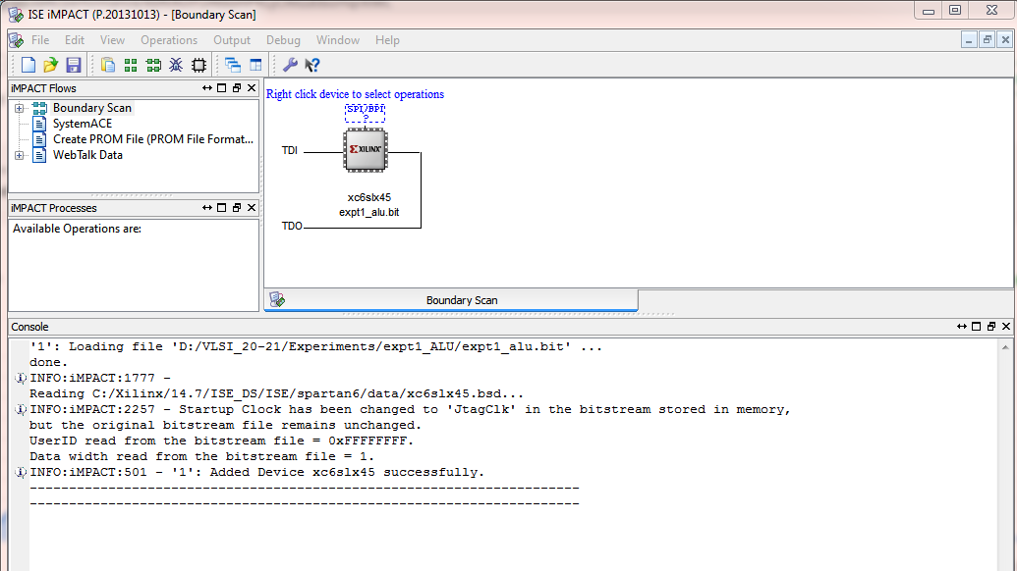

Hardware Snapshots
Digilent ATLYS Spartan 6 FPGA Board
